Appendix-IX

MANDATORY PUBLIC DISCLOSURE

- General Information:

Sl. No. | Information | Details
1 | Name of the School | MEDHA MONTESSORI SCHOOL
2 | Affiliation No. (If applicable) | NA
3 | School Code (If applicable) | NA
4 | Complete Address with Pin Code | 6-120 /1, PEDDAMANGALARAM, MOINABAD (M), RANGA REDDY DISTRICT, TELANGANA, RANGAREDDY, TELANGANA - 501504
5 | Principal Name & Qualification | MADHAVI GADDAM, B.COM, M.Ed
6 | School Mail ID | medhamontessorihyd@gmail.com
7 | Contact Details(Landline/Mobile) | 9440233288, 9490422220

- Documents and Information

Sl. No. | Documents/Information | View
1 | Copies of affiliation/upgradation letter and recent extension of affiliation, if any | NA
2 | Copies of Societies/Trust/ Company Registration/ Renewal certificate, as applicable | Click Here
3 | Copy of NO OBJECTION CERTIFICATE (NOC) issued, if applicable, by the State Govt./UT | Click Here
4 | Copies of Recognition certificate under RTE Act, 2009, and its renewal if applicable | Click Here
5 | Copy of valid Building Safety Certificate as per the National Building Code | Click Here
6 | Copy of Valid Fire Safety Certificate issued by the competent authority | Click Here
7 | Copies of valid Water, Health and Sanitation certificates | Click Here

- Result and Academics

Sl. No. | Documents/Information | View
1 | Fee Structure of the School | Click Here
2 | Annual Academic Calendar | Click Here
3 | List of School Management Committee (SMC) | Click Here
4 | List of Parents Teachers Association (PTA) members | Click Here
5 | Last Three-Year Result of the Board Examination as per applicability | Click Here

- Staff(Teaching)

Sl. No. | Documents/ Information | Details
1 | Principal | 1
2 | Total No.of Teachers | 1
 | PGT | 12
 | TGT | 2
 | PRT | 6
 | Others | 4
3 | Teachers Section Ratio | 1:1
4 | Details of Special Educator | ---
5 | Details of Counsellor and WellnessTeacher | M.Sreeya Reddy

- School Infrastructure

Sl. No. | Documents/ Information | Details
1 | Total Campus Area of the school (in Square Mtr) | 8,093.72 sq.mtr
2 | No. and size of the classrooms (in Square Mtr) | Primary 174 Sq meter Mixed Aged Class room – 1  Elementary 145 Sq meter Mixed Aged Class room - 1  Class Rooms 58 Sq meter - 3  Office Room 36 Sq meter - 1  Staff Rooms 9 Sq meter - 2  Wellness room 13 Sq meter - 1
3 | No. and size of Laboratories including computer Labs(in Sq. Mtr) | Composite Lab 116 Sq meter  Computer lab 36 Sq meter - 1
4 | Internet Facility (Y/N) | Available
5 | No. of Girls Toilets | 10
6 | No. of Boys Toilets | 10
7 | Link of Youtube video of the  inspection of school covering the Infrastructure of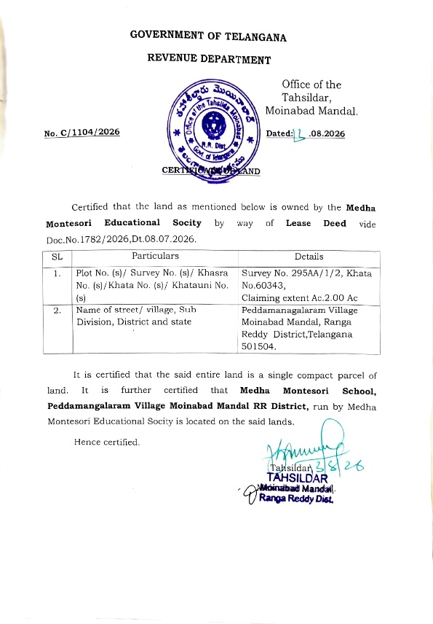 the school | https://youtu.be/Hln_scBDKoM?si=aLX-tBG0yfR  Copy past the link in the browser if the ink is not working

